leqcia 2
1.2. funqciis grafikis ageba. martivi magaliTebi.
trigonometriuli funqciebis grafikebis ageba
funqciis grafikis agebis diferencialuri meTodi Sedgeba Semdegi 9 nabijisgan:
1. funqciis gansazRvris aris povna; luw-kentobis da periodulobis dadgena;
2. wyvetis wertilebis povna; wyvetis wertilebSi calmxrivi zRvrebis gamoTvla;
3. sakoordinato RerZebTan TanakveTis wertilebis povna;
4. usasrulobaSi funqciis yofaqcevis Seswavla;
5. zrdadobisa da klebadobis intervalebis povna;
6. funqciis gamokvleva eqstremumze;
7. funqciis zemoT amozneqilobis, qvemoT amozneqilobis Sualedebis dadgena; gadaRunvis wertilebis povna;
8. funqciis asimptotebis povna;
9. pirveli rva punqtis gamoyenebiT grafikis ageba.

meTodis ilustrireba movaxdinoT Semdegi oTxi martivi funqciis magaliTze:
a) $y=x$; (1.2.1)
b) $y=\frac{1}{x}$; (1.2.2)
g) $y=x^{2}$; (1.2.3)
d) $y=\text{sin}x$. (1.2.4)

1. movZebnoT (1.2.1), (1.2.2), (1.2.3), (1.2.4) funqciebis gansazRvris areebi.
a) $y=x$ funqciis gansazRvris area $x∈]−∞;+∞[$, an, rac igivea, $x∈R^{1}$.
b) $y=\frac{1}{x}$ funqcia gansazRvrulia nebismieri wertilSi $R^{1}$-dan, garda 0-sa, e. i. $x∈]−∞;0[∪]0;+∞[$.
g) $y=x^{2}$ funqciis gansazRvris area $x∈]−∞;+∞[$.
d) $y=\text{sin}x$ funqciis gansazRvris area $x∈]−∞;+∞[$.
gavarkvioT TiToeuli funqciis luw-kentoba.

a) $f(x)=x$. ganvixiloT $f(−x)$.
$f(−x)=−x=−f(x)$, e. i. funqcia kentia.

b) $f(x)=\frac{1}{x}$. ganvixiloT
$f(−x)=\frac{1}{−x}=−\frac{1}{x}=−f(x)$, e. i. funqcia kentia.
g) $f(x)=x^{2}$. ganvixiloT
$f(−x)=(−x)^{2}=x^{2}=f(x)$, e. i. funqcia luwia.

d) $f(x)=\text{sin}x$. ganvixiloT
$f(−x)=\text{sin}(−x)$. (1.2.5)
nax. 1.2.1-ze mocemulia r-radiusiani wre. I meoTxedSi gadavzomoT $α$ radianis toli kuTxe. $\text{sin}α$-s ganmartebis Tanaxmad
O
nax. 1.2.1
$\text{sin}α=\frac{y}{r}$.
cxadia,
$\text{sin}(−α)=\frac{−y}{r}=−\frac{y}{r}=−\text{sin}α$.
bolo tolobis ZaliT, (1.2.5) toloba Semdegi saxiT gadaiwereba
$f(−x)=\text{sin}(−x)=−\text{sin}x=−f(x)$,
e. i. $y=\text{sin}x$ funqcia kentia.
SeniSvna 1.2.1. $y=\text{sin}x$ funqcia I da II meoTxedebSi dadebiT mniSvnelobebs iRebs, xolo III da IV meoTxedebSi _ uaryofiTs.
perioduloba.
a) $f(x)=x$.
$f(x+l)=x+l=x$ maSin da mxolod maSin, roca $l=0$, rac imas niSnavs, rom (1.2.1) funqcia ar aris perioduli.
b) $f(x)=\frac{1}{x}$.
$f(x+l)=\frac{1}{x+l}=\frac{1}{x}$ maSin da mxolod maSin, roca $l=0$, rac imas niSnavs, rom (1.2.2) funqciac araperiodulia.
g) analogiurad mtkicdeba, rom (1.2.3) funqciac araperiodulia. marTlac,
$f(x+l)=(x+l)^{2}=x^{2},$ $x^{2}+2\text{lx}+l^{2}=x^{2},$ $l(2x+l)=0\text{.}$ magram es ukanaskneli Sesruldeba maSin da mxolod maSin, roca $x=−\frac{l}{2}$ da ara nebismieri namdvili $x$-isaTvis.
d) (1.2.4) funqcia periodulia da misi umciresi dadebiTi periodia $2π$. marTlac, radgan
$\text{sin}(2π+x)=\text{sin}2π\text{cos}x+\text{cos}2π\text{sin}x=\text{sin}x$,
amitom $2π$ warmoadgens erT-erT periods, rac nax. 1.2.1-danac cxadia. vaCvenoT, rom is umciresi dadebiTi periodia. Tu davuSvebT, rom $0<l<2π$ periodia, maSin
$$\text{sin}(x+l)=\text{sin}x$$
nebismieri x-sTvis, maT Soris $x=0$-sTvisac. es imas niSnavs, rom
$\text{sin}l=\text{sin}0=0$,
rac marTebulia $2π$-ze naklebi mxolod erTi $l=π$ mniSvnelobisTvis. magram $π$ ar warmoadgens $\text{sin}x$-is periods, radgan $\text{sin}\frac{π}{2}=1$, $\text{sin}\left(\frac{π}{2}+π\right)=−1$.

2. gavarkvioT funqciis wyvetis wertilebis sakiTxi.
a) $y=x$ funqcias wyvetis wertilebi ar gaaCnia.
b) $y=\frac{1}{x}$ funqciis wyvetis wertilia $x=0$. vipovoT (1.2.2) funqciis calmxrivi zRvrebi wyvetis wertilSi
$\underset{x→0+}{\text{lim}}\frac{1}{x}\text{=+}∞$, $\underset{x→0−}{\text{lim}}\frac{1}{x}=−∞$.
(1.2.3) da (1.2.4) funqciebs wyvetis wertilebi ar gaaCnia.
3. funqciis grafikis x da y RerZebTan TanakveTis wertilebis mosaZebnad Sesabamisad y da x cvladebi unda gavutoloT nuls.
a) $y=x$ funqciis grafiki gadis koordinatTa saTaveze, e. i. (0,0) wertilze.
b) $y=\frac{1}{x}$ funqciis grafiki ar kveTs sakoordinato RerZebs.
g) $y=x^{2}$ funqciis grafiki gadis (0,0) wertilze.
d) $y=\text{sin}x$ funqciis grafiki x RerZs kveTs, roca $\text{sin}x=0$, e. i. $x=kπ$, $k=0, ±1, ±2,…$ wertilebSi, y RerZs ki _ (0,0) wertilSi, radgan $y=\text{sin}0=0$.

4. funqciis yofaqceva usasrulobaSi.
a) $\underset{x→±∞}{\text{lim}}x=±∞$.
b) $\underset{x→±∞}{\text{lim}}\frac{1}{x}=0$.
g) $\underset{x→±∞}{\text{lim}}x^{2}\text{=+}∞$.
d) $\underset{x→±∞}{\text{lim}}(\text{sin}x)$ ar arsebobs.

5. zrdadoba-klebadobis sakiTxis dadgena.
a) $f(x)=x$.
$f'(x)=1>0$, e. i. funqcia zrdadia gansazRvris mTel areze.
b) $f(x)=\frac{1}{x}$.
$f'(x)={\left(x^{−1}\right)}^{′}=(−1)x^{−2}=−\frac{1}{x^{2}}<0$ nebismieri $x≠0$-sTvis. funqcia klebadia Tavis gansazRvris areze.
g) $f(x)=x^{2}$.
$$f'(x)={\left(x^{2}\right)}^{′}=2xalignl\begin{aligned}\left\{0,\text{ roca }x>0,\text{ e}\text{.}\text{ i}\text{.}\text{ zrdadia, roca }x∈[0;+∞[, | \right.\end{aligned}$$
d) $f(x)=\text{sin}x$.
$$f'(x)=\text{cos}xalignl\begin{aligned}\left\{0,\text{ I da IV meoTxedebSi, e}\text{.}\text{ i}\text{.}\text{ iq zrdadia,} | \right.\end{aligned}$$

6. funqciis eqstremumis wertilebis moZebna.
a) $f(x)=x$.
$f'(x)=1≠0$, e. i. $y=x$ funqcias eqstremumis wertilebi ar aqvs.
b) $f(x)=\frac{1}{x}$.
$f'(x)=−\frac{1}{x^{2}}≠0$, e. i. $y=\frac{1}{x}$ funqcias eqstremumis wertilebi ar aqvs.
g) $f(x)=x^{2}$.
$f'(x)=2x=0$, roca $x=0$.
$x=0$ eqstremumis wertilia. imis gasarkvevad, es wertili maqsimumis wertilia Tu minimumis, saWiroa, vipovoT $f\text{ \backslash ( x \backslash ) \} \{}$:
$f\text{ \backslash ( x \backslash ) =2>0\} \{}$,
e. i. $x=0$ minimumis wertilia.
d) $f(x)=\text{sin}x$.
$f'(x)=\text{cos}x=0$, roca $x=\frac{π}{2}+πk$, $k=0; ±1; ±2;…$.
ganvixiloT $f\text{ \backslash ( x \backslash ) \} \{}$:
$f\text{ \backslash ( x \backslash ) = - }sin\text{x drarrow f}\left(\frac{π}{2}+πk\right)=−\text{sin}\left(\frac{π}{2}+πk\right)=−\text{cos}πkalignl\begin{aligned}\left\{0,\text{ roca }k=2j, | \right.\end{aligned}$$j=0; ±1; ±2;$....
miviReT, rom $x=\frac{π}{2}+2πj$, $j=0, ±1, ±2$,$…$ funqciis maqsimumis $\left[\text{sin}\left(\frac{π}{2}+2πj\right)=1\right]$ wertilebia, xolo $x=\frac{π}{2}+π(2j+1)$*), e. i. $x=−\frac{π}{2}+2πj$,^{*)} $j=0$, $±1$, $±2$,$…$, funqciis minimumis $\left[\text{sin}\left(−\frac{π}{2}+2πj\right)=−1\right]$ wertilebia.

7. funqciis zemoT amozneqiloba, qvemoT amozneqiloba; gadaRunvis wertilebis povna.
a) $f(x)=x$.
$f\text{ \backslash ( x \backslash ) =0\} \{}$, e. i. $y=x$ funqcia ar aris arc zemoT amozneqili da arc qvemoT amozneqili.
b) $f(x)=\frac{1}{x}$.
$$f\text{ \backslash ( x \backslash ) = left ( \{ \{1\} over \{x\} \} right ) rSup \{ size 8\{}={\left(−x^{−2}\right)}^{'}=\frac{2}{x^{3}}\begin{aligned}\left\{0,\text{ roca }x>0, | \right.\end{aligned}$$
e. i. $y=\frac{1}{x}$ funqciis grafiki $x∈]0;+∞[$ SualedSi qvemoT amozneqilia, xolo $x∈]−∞;0[$ SualedSi _ zemoT amozneqili.
g) $f(x)=x^{2}$.
$f\text{=2>0\} \{}$, e. i. funqciis grafiki qvemoT amozneqilia.
d) $f(x)=\text{sin}x$.
$$f\text{ \backslash ( x \backslash ) = - }sin\text{xalignl \{ stack \{ left lbrace >0,}IIIdaIVmeoTxedebSi,\text{ \{\} \# right none left lbrace <0,}IdaIImeoTxedebSi,\text{ \{\} \# right no \} \} lbrace \} \{}$$
e. i. funqciis grafiki qvemoT amozneqilia, roca $x∈]−π+2πk,2πk[$, zemoT amozneqilia, roca $x∈]2πk,π(1+2k)[$, $k=0; ±1; ±2; ⋯$. cxadia, rom
$f\text{ \backslash ( πk \backslash ) = - }sin\text{ \backslash ( πk \backslash ) =0\} \{}$,
rac imas niSnavs, rom $x=πk$ gadaRunvis wertilebia.
gamovTvaloT gadaRunvis $0$ da $π$ wertilebSi gavlebul mxebTa mier $x$ RerZTan Sedgenili kuTxeebi. wirisadmi gavlebuli mxebis gantolebis formulidan Sesabamisad gveqneba
$y−\text{sin} 0=\text{sin'} 0 ⋅ (x−0)$ da $y−\text{sin} π=\text{sin'} π ⋅ (x−π)$,
e.i.
$y=\text{cos} 0 ⋅x$ da $y=\text{cos} π ⋅(x−π)$.
saidanac $y=x$ da $y=−x+π$. magram, radgan sakuTxo koeficienti $\text{tg}α=m=f'(x_{0})$, amitom $\text{tg}α=1$, roca $x_{0}=0$, da $\text{tg}α=−1$, roca $x_{0}=π$. Sesabamisad $α=\frac{π}{4}$, roca $x_{0}=0$, da $α=−\frac{π}{4}$ an rac igivea $α=\frac{3π}{4}$, roca $x_{0}=π$.

8. asimptotebis povna.
a) (1.2.1) funqciis grafiks asimptotebi ar aqvs. marTlac,
$$k=\underset{x→±∞}{\text{lim}}\frac{f(x)}{x}=\underset{x→±∞}{\text{lim}}\frac{x}{x}=\underset{x→±∞}{\text{lim}}1=1;$$
$$b=\underset{x→±∞}{\text{lim}}[f(x)−\text{kx}]=\underset{x→±∞}{\text{lim}}(x−x)=0\text{.}$$
kvlav miviReT $y=x$ funqcia, romlis asimptotasac veZebT. magram asimptota ar SeiZleba grafiks kveTdes (roca wiris wertili usasrulobaSi miiswrafis), miT ufro emTxveodes.
b) (1.2.2) funqciis grafikis horizontaluri asimptotaa $y=0$, vertikaluri asimptota ki _ $x=0$; daxrili asimptotebi ar gaaCnia. marTlac,
$$k=\underset{x→±∞}{\text{lim}}\frac{f(x)}{x}=\underset{x→±∞}{\text{lim}}\frac{\frac{1}{x}}{x}=\underset{x→±∞}{\text{lim}}\frac{1}{x^{2}}=0;$$
$$b=\underset{x→±∞}{\text{lim}}[f(x)−\text{kx}]=\underset{x→±∞}{\text{lim}}\frac{1}{x}=0\text{.}$$
amrigad, asimptotaa $y=0⋅x+0=0\text{.}$ es ukanaskneli ki horizontaluri asimptotaa. radgan $\underset{x→0+}{\text{lim}}f(x)=\underset{x→0+}{\text{lim}} \frac{1}{x}\text{=+}∞$ da $\underset{x→0−}{\text{lim}}f(x)=\underset{x→−}{\text{lim}} \frac{1}{x}=−∞$, amitom $x=0$-s, e.i., $y$ RerZi vertikaluri asimptotaa.
g) (1.2.3) funqciis grafiks asimptotebi ar aqvs. marTlac,
$$k=\underset{x→±∞}{\text{lim}}\frac{f(x)}{x}=\underset{x→±∞}{\text{lim}}\frac{x^{2}}{x}=\underset{x→±∞}{\text{lim}}x=±∞\text{.}$$
radgan $k$ sasruli unda iyos, daxrili da horizontaluri asimptotebi ar arsebobs. vinaidan $y=x^{2}$ funqcia mTel RerZzea gansazRvruli, arc vertikaluri asimptota ar arsebobs.
d) (1.2.4) funqciis grafiks asimptotebi ar aqvs. marTlac,
$$k=\underset{x→±∞}{\text{lim}}\frac{f(x)}{x}=\underset{x→±∞}{\text{lim}}\frac{\text{sin} x}{x}=0;$$
$$b=\underset{x→±∞}{\text{lim}}[f(x)−\text{kx}]=\underset{x→±∞}{\text{lim}}(\text{sin} x−0⋅x)=\underset{x→±∞}{\text{lim}} \text{sin} x$$
es ukanaskneli ki ar arsebobs. amrigad, daxrili da horizontaluri asimptota ar arsebobs. radgan $\text{sin} x$ mTel RerZzea gansazRvruli, amitom vertikaluri asimptotac ar arsebobs.

9. grafikis ageba (ix. nax. 1.2.2 _1.2.5).

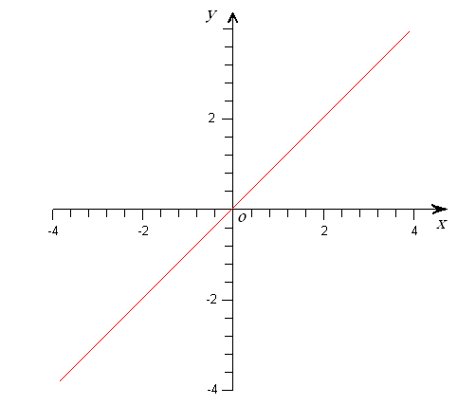
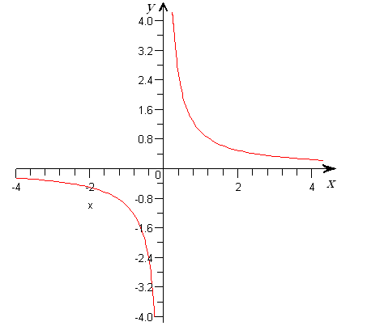
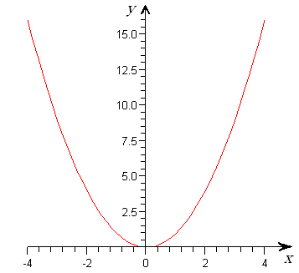
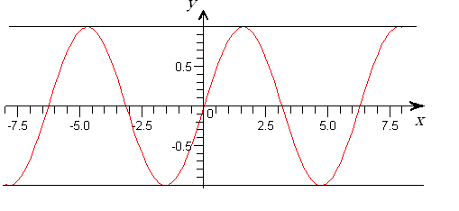
analogiurad aigeba sxva trigonometriuli funqciebis $(y=\text{cos}x, y=\text{tgx}, y=\text{ctgx})$ grafikebi.
nax. 1.2.2
nax. 1.2.3
nax. 1.2.4
nax. 1.2.5

* ) wertilTa es simravleebi rom erTi da igivea, advilad davrwmundebiT $j=k−1$ ($j,k=0$, $±1$, $±2$, $…$) CasmiT.

